**APPLIED DATA SCIENCE CAPSTONE PROJECT**

**The Battle of Neighborhoods**

**Starting an ethnic Korean Restaurant in New York City**

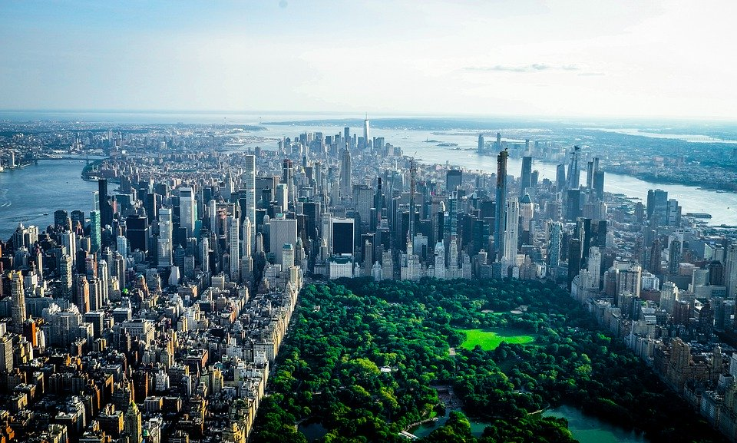

**BY**

**FAENZO BLOM**

**Introduction**

NYC is the cultural center of the world. Visitors from around the country and all over the world come here to enjoy the many different types of cultural amenities. The lifestyle of the people within the city is, itself, a culture form. The energy, the bustle, the array of stores serving every income level and ethnic group, the mix of languages and newspapers, are all part of its living culture.

There is a large demographic within New York and it is one of the most diverse Cities in America. The 2019 population statistics show that the population stands at roughly 8.3 Million people. The New York region continues to be by far the leading metropolitan gateway for legal immigrants admitted into the United States. New York City has also been a major point of entry for immigrants. As many as 800 languages are spoken in New York, making it the most linguistically diverse city in the world.

There are many restaurants in New York City, each belonging to different categories like Chinese, Indian, and French etc. A fairly newer introduction to this range has been the Korean Restaurants which have arrived out of nowhere and been making its mark on the City. Koreatown (K-Town), in Manhattan, may be a long way from Seoul but it has become a great place to get the best delectable national dishes.

Though New York City's K-Town is one of the country's flashiest, it's hardly an isolated example. LA, Atlanta, Fort Lee, Houston, and many of other cities all have robust Koreatowns of their own. And Korean flavors are making their way into more and more non-traditional restaurants.

What better place to open a Restaurant than the City of Dreams, NEW YORK.

So let’s start our journey to see what information we can find out to make the best decision.

**Business Problem**

Our objective is to research:

1. The best location for our Korean restaurant,
2. What our competition will look like in that area and
3. Which areas lack Korean Restaurants?

**Data**

The following data is required for this project:

* New York City data containing the neighborhoods and boroughs.
* Latitude and longitude coordinates of those neighborhoods. This is required to plot the map and get the venue data.
* Venue data, particularly data related to restaurants. We are going to use this data to perform further analysis of the neighborhoods.

A combination of data science skills will be required to complete this task. Some examples are web scrapping (open source dataset), working with API (Foursquare), data cleaning, data wrangling, to map visualization (Folium).

**Methodology**

We will need to use the following to source the data:

* Neighborhood data - https://cocl.us/new_york_dataset
* Venue Data – Foursquare will be utilized
* Visual assessment of data – Watson Studio utilizing Python Libraries

**We will set up our data first.**

Step 1: Import Libraries required

Step 2: Data will be collected from <https://cocl.us/new_york_dataset>. We will need to clean and process this into a dataframe.

Step 3: We will utilize Foursquare to locate all venues and then filter to obtain only Korean restaurants. Ratings, tips, and likes by users will be counted and added to the data frame.

Step 4: Data will be sorted based on rankings.

*Next we will assess this data with the utilization of the Python libraries imported in the first step.*

Step 5: We will then sort Neighbourhoods and Borough the data keeping Ratings as the constraint.

Step 6: We will then look at all the neighborhoods with an average rating of 7.0 or greater.

Step 7: We Will complete this by visualize the Neighbourhoods and Borough based on average Rating using python’s Folium library.

**Results**

Our results as follows:

1. We see that the number of neighborhoods in each Borough are as follows (in descending order):
2. Queens 2. Brooklyn 3. Staten Island 4. Bronx 5.Manhattan

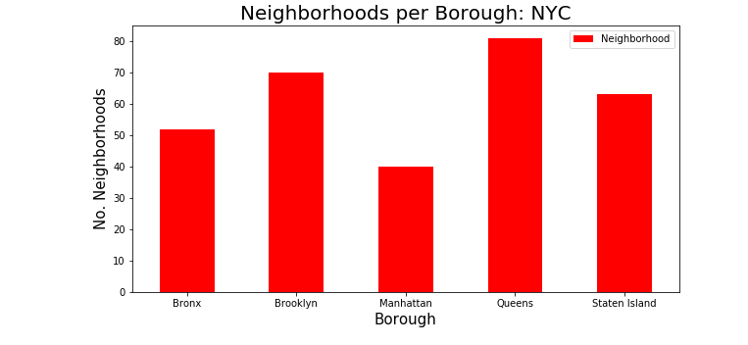

1. Queens has the most Korean Restaurants as can be seen below:

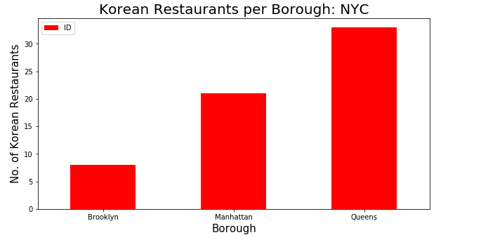

1. Murray Hill neighborhood in Manhattan has the highest number of Korean Restaurants with a total count of 18. The second highest is Midtown South which is also in Manhattan.

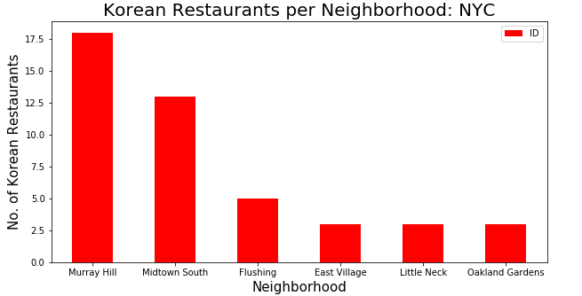

1. The Borough with the highest average rating for Korean Restaurants is Manhattan. Brooklyn goes right behind with the average rating only a little lower than that of Manhattan.

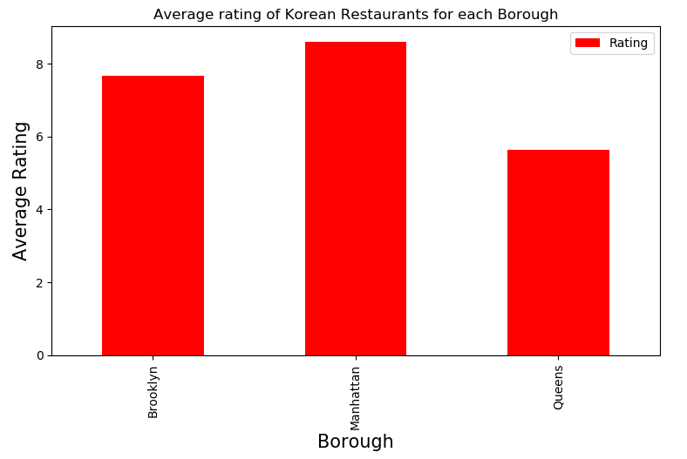

1. The two Neighborhoods with the highest average rating for Korean Restaurants are Tribeca and East Village with 8.9 and 8.8 respectively. They are both located in Manhattan. 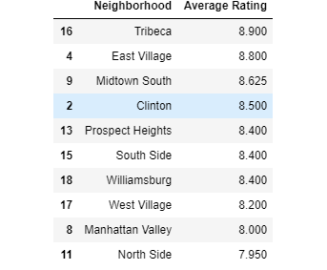

**Discussion**

Based on the results and interpretation of our analysis, I would state that Brooklyn is the best location to open up a Korean Restaurant.

When comparing Brooklyn to Manhattan it is a close second in terms of ratings, has a higher number of neighborhoods (Options) and has the least number of Korean Restaurants and therefore less competition. We can also, off the cuff, take into account that Real Estate prices are cheaper than in Manhattan.

When comparing Brooklyn to Queens it has a much higher rating and is a close second in terms of Neighborhoods. It also has a lot less Korean Restaurants which means less competition.

**Conclusions**

The importance of Data Science has been highlighted in this Report. The best Korean Restaurants are located in Manhattan and the most are located in Queens. However, as can be seen above that doesn’t always result in the best choice. This is why all factors need to be considered when making such an important decision and further indicates why this process need to be taken into consideration.

This is a valuable exercise and tool for any person interested in opening a Korean Restaurant within New York.